MDP’s 2017

Vacation Bible School!
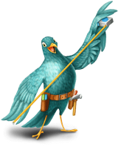

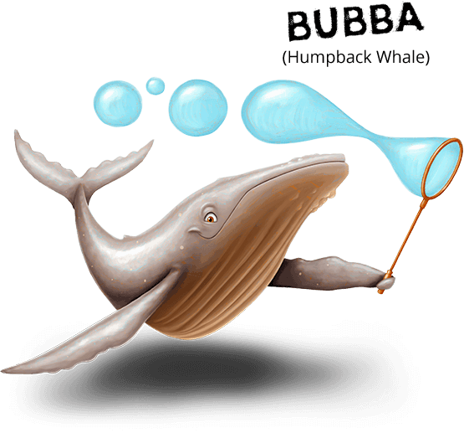

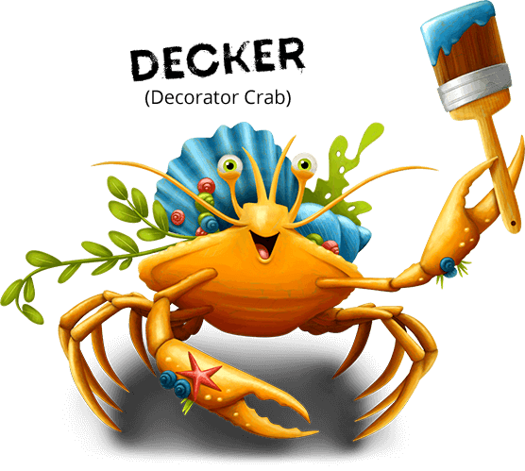
Mother of Divine Providence Parish Gym & School
June 26 – 30, 2017 at 9am – 12noon
VBS Campers: Kids entering K – 5th/ Counselors: 6th – 12th
Adult Volunteers: Needed!
*Children of adult volunteers attend for FREE!*

Volunteer dates:
Adult Staff Meeting – Thursday June 15th, 6:30pm – 8:00pm
Teen Training Days: shared via email
Return form & check to Lauren Joyce at MDP Parish!
Due Date June 1st! (We fill up quickly… don’t delay!)

Family Info:
Parent Name(s):

Family Address:

Parent email(s) for VBS updates:
*all communications come via email!*
Emergency Contact 1:  Phone 1:  Relationship to Children: | Emergency Contact 2:  Phone 2:  Relationship to Children:
Aside from listed parents & emergency contacts, may anyone else drive your kids home?

Are there custody / legal issues? If so, please explain:
**Will anyone over 18 be helping as a volunteer? Names & emails:
Camper & Counselor Info:
Child Name (under 18):
Age on June 26, 2017: | CAMPER or COUNSELOR?  (Entering K – 5th) (Entering 6th-12th)
Special needs / food allergies / medicines
/ safety notes, including Epi-Pens:
Child Name (under 18):
Age on June 26, 2017: | CAMPER or COUNSELOR?  (Entering K – 5th) (Entering 6th-12th)
Special needs / food allergies / medicines
/ safety notes, including Epi-Pens:
Child Name (under 18):
Age on June 26, 2017: | CAMPER or COUNSELOR?  (Entering K – 5th) (Entering 6th-12th)
Special needs / food allergies / medicines
/ safety notes, including Epi-Pens:

c
Signature of Parent / Legal Guardian below includes the following items:
PARENTAL PERMISSION AND RELEASE My child(ren) listed on this form have my permission to participate in the 2017 Vacation Bible School (VBS) at Mother of Divine Providence (MDP) Parish from June 26-30, 2017. I hereby agree to indemnify and hold harmless MDP Catholic Church, the Archdiocese of Philadelphia and its officers, employees, and volunteer staff from any liability. I accept responsibility for any medical expenses as a result of any injury sustained. EMERGENCY MEDICAL CARE PERMISSION I give permission that, in my absence, my children whose names appear on this registration form may receive emergency medical care for injuries and all situations that may occur while participating in the VBS and activities at MDP. PHOTO RELEASE PERMISSION I give permission for my children’s pictures to appear on MDP website or other forms of community news. No names will be used.
Signature: _______________________________________Date: ______________________
Cost for my family: ________________ Campers = $45 Counselors = $20 Family Max = $100
Adult volunteers = free & their kids free

